**Experiment 3**

**Aim:** To implement merge sort.

**Code:**

#include <iostream>

using namespace std;

void Merge(int *arr, int si, int ei, int mid){

int a[100],b[100],c[100];

int m=0,n=0;

for(int i=si;i<=mid;i++){

a[m]=arr[i];

m++;

}

for(int i=mid+1;i<=ei;i++){

b[n]=arr[i];

n++;

}

int j=0,k=0,l=0;

while(j<m && k<n){

if(a[j]<=b[k]){

c[l]=a[j];

l++;

j++;

}

else{

c[l]=b[k];

l++;

k++;

}

}

if(j==m){

while(k<=n){

c[l]=b[k];

l++;

k++;

}

}

else{

while(j<=m){

c[l]=a[j];

l++;

j++;

}

}

int p=0;

for(int i=si;i<=ei;i++){

arr[i]=c[p];

p++;

}

}

void Split(int *arr,int si,int ei){

if(si>=ei){

return;

}

int mid=(si+ei)/2;

Split(arr,si,mid);

Split(arr,mid+1,ei);

Merge(arr,si,ei,mid);

}

void Merge_Sort(int *arr, int n){

int si=0,ei=n-1;

Split(arr,si,ei);

}

int main(){

int n;

cout<<"Merge Sort Algorithm"<<endl;

cout<<"Best Case Time Complexity is: O(n*logn)"<<endl;

cout<<"Worst Case Time Complexity is: O(n*logn)"<<endl;

cout<<"Space Complexity is: O(n)"<<endl;

cout<<"Enter the size of an array (Total entries should not be more than 100): ";

cin>>n;

int *arr = new int [100];

cout<<"Enter the array elements: ";

for(int i=0;i<n;i++){

cin>>arr[i];

}

cout<<"The original array is: ";

for(int i=0;i<n;i++){

cout<<arr[i]<<" ";

}

cout<<endl;

Merge_Sort(arr,n);

cout<<"The sorted array in ascending order is: ";

for(int i=0;i<n;i++){

cout<<arr[i]<<" ";

}

cout<<endl;

delete arr;

}

**Output:**

1. **Best Case**

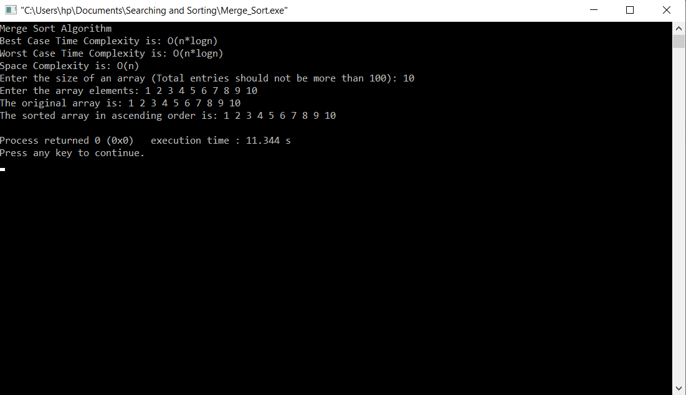

1. **Worst Case**

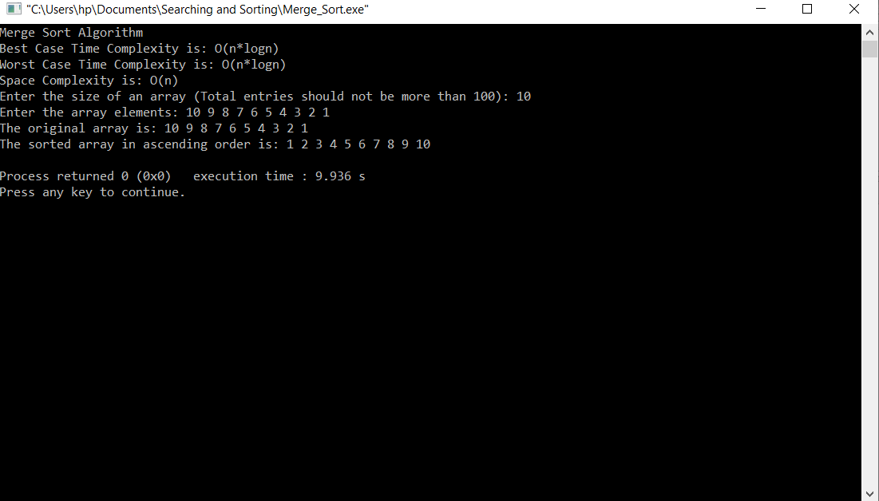

**Conclusion:** The merge sort sorting algorithm has been implemented successfully.